**INTRODUCTION**

**1.1 Project overview**

**Project Title:**  
Visualization Tool for Electric Vehicle Charge and Range Analysis

**Objective:**  
To design and implement an interactive visualization tool that enables users (e.g., EV owners, researchers, fleet managers) to analyze electric vehicle charging patterns, battery usage, and driving range under varying conditions in real-time or through historical data.

**1.2 Purpose**

The primary purpose of the visualization tool is to:

* **Enhance the understanding** of EV charging behavior and energy consumption through interactive visuals.
* **Track and analyze** the state of charge (SoC), range estimations, and charging station usage.
* **Enable smarter planning** for trips based on range availability, terrain, and past usage data.
* **Support decision-making** for fleet management and EV infrastructure optimization.
* **Promote energy-efficient driving** by identifying patterns in range performance and charge cycles.

By converting technical EV data into visual formats that are easy to interpret, the tool empowers users to engage with their vehicle data more effectively and make more sustainable choices.

**2. IDEATION PHASE**

**2.1 Problem Statement**

Electric Vehicles (EVs) are becoming increasingly popular, but users often face challenges in understanding battery performance, energy consumption, and estimated range under varying conditions. The lack of intuitive and accessible tools to visualize such data results in inefficient charging behavior, route planning issues, and range anxiety. Moreover, raw data logs or complex technical dashboards often do not cater to the average user’s needs for clarity and actionable insights.

There is a need for a **user-friendly, data-driven visualization tool** that helps users analyze charging patterns, battery usage, and range predictions using interactive charts, maps, and real-time feedback.

**2.2 Empathy Map Canvas**

This canvas outlines the needs, feelings, and behaviors of the **primary user persona** (e.g., an EV owner or fleet manager):

| **Section** | **Details** |
| --- | --- |
| **Says** | “I need to know how far I can go on my current charge.” “Charging takes too long and I don't know when it's optimal.” |
| **Thinks** | “Am I using my EV efficiently?” “How can I plan long trips with accurate range data?” |
| **Does** | Frequently checks the EV dashboard or app for battery status. Looks for nearby charging stations on navigation apps. |
| **Feels** | Anxious about running out of charge unexpectedly. Frustrated by vague or technical data formats. |

**User Need:** A tool that simplifies EV charge and range data into interactive, easy-to-understand visuals.

**2.3 Brainstorming**

**Ideas for Visualization Features**

* **Interactive Dashboard:** Visualize State of Charge (SoC), remaining range, trip distance, and energy consumption.
* **Real-Time Map View:** Show nearby charging stations, their status (available/busy), and estimated range overlays.
* **Comparison Graphs:** Battery efficiency vs. time, temperature, terrain, or speed.
* **Charging Session Log:** Visual display of past charging sessions with duration, cost, and battery percentage change.
* **Trip Planner Integration:** Plan routes based on terrain and charging station availability.
* **Mobile Compatibility:** Responsive interface for smartphones and tablets.
* **Downloadable Reports:** Export daily/weekly usage reports in PDF or CSV.

**Tech Ideas and Tools**

* **Frontend Libraries:** React.js, D3.js, Chart.js
* **Mapping APIs:** Leaflet.js or Mapbox
* **Backend:** Flask / FastAPI (Python), with data from CSV, API, or MQTT telemetry
* **Data Storage:** PostgreSQL or MongoDB
* **Predictive Models:** Use machine learning for range estimation based on historical driving behavior and environmental factors.

**3. REQUIREMENT ANALYSIS**

**3.1 Customer Journey Map**

| **Stage** | **Customer Action** | **Experience** | **Touchpoints** | **Pain Points** |
| --- | --- | --- | --- | --- |
| **Awareness** | Learns about the visualization tool | Curious, skeptical | Online ads, social media, word of mouth | Unsure if tool supports their EV model |
| **Onboarding** | Registers/logs into the tool | Interested, cautious | Registration page, dashboard | Complexity in initial setup, unfamiliar interface |
| **Exploration** | Uploads or connects EV data | Engaged, slightly overwhelmed | Upload screen, live data connector | Unsure what to look for in the graphs and charts |
| **Interaction** | Views charge patterns, range analysis on dashboard | Informed, empowered | Visual dashboard, map, filters | Data overload without filtering |
| **Decision** | Uses tool to plan a trip or optimize charging | Confident, satisfied | Route planner, prediction engine | Range still varies due to real-world uncertainties |
| **Retention** | Continues usage weekly/monthly | Loyal, feedback-driven | Notifications, reports, updates | Wants personalization, alerts for low range or battery issues |

**3.2 Solution Requirements**

**Functional Requirements**

* User authentication and profile management
* Upload/import of EV charge and range data
* Real-time data visualization dashboard
* Map integration for route and charging station display
* Filtering and comparison tools (e.g., by time, trip, condition)
* Export reports (CSV, PDF)
* Predictive range estimator based on historical data

**Non-Functional Requirements**

* Responsive UI (mobile/tablet support)
* Fast data processing and load times
* Secure data handling and encryption
* Scalable backend to support growing user base
* Compatibility with various EV data formats/APIs

**3.3 Data Flow Diagram (Level 1)**

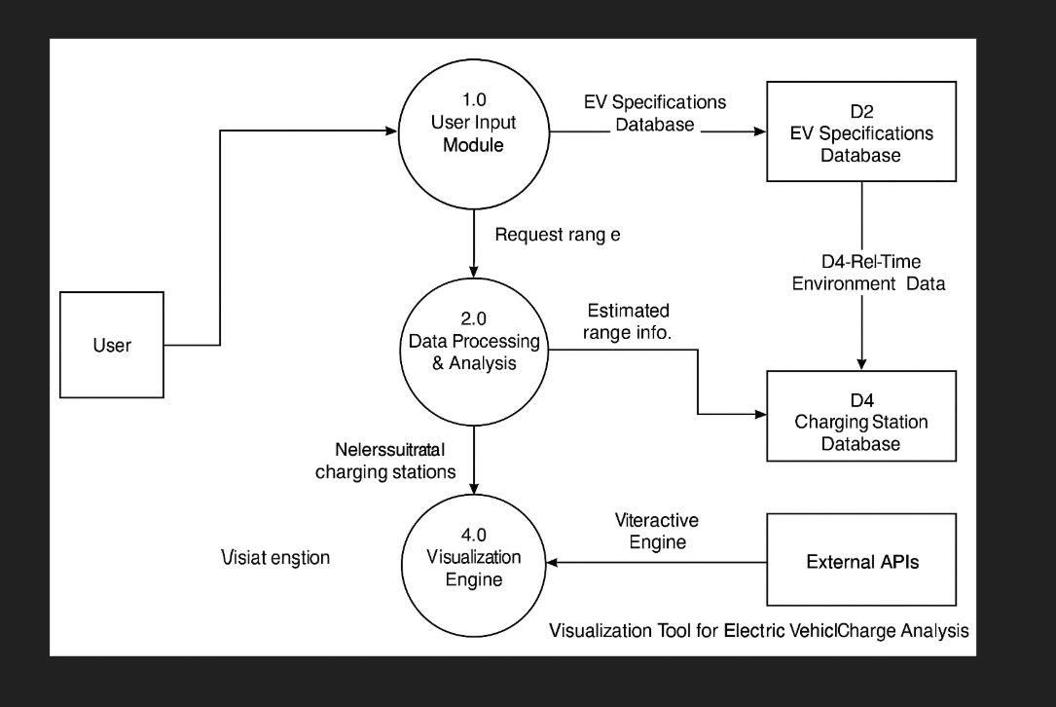

**Components:**

* **Input:** User login, EV data upload
* **Processing:** Data parsing, analytics, prediction modeling
* **Output:** Interactive charts (line, bar, pie), maps (range overlays, station info)
* **Storage:** Structured or semi-structured databases

**3.4 Technology Stack**

| **Layer** | **Technology** |
| --- | --- |
| **Frontend (UI)** | HTML5, CSS3, JavaScript (React.js), Tailwind CSS |
| **Visualization** | D3.js, Chart.js, Plotly, Leaflet.js (for maps) |
| **Backend (API)** | Python (Flask or FastAPI) |
| **Database** | PostgreSQL (relational) / MongoDB (NoSQL) |
| **Data Integration** | CSV import, REST APIs, Telemetry (MQTT/IoT) |
| **Authentication** | JWT tokens, OAuth2 (optional) |
| **Deployment** | Docker, AWS/GCP, GitHub CI/CD |

**4. PROJECT DESIGN**

**4.1 Problem-Solution Fit**

**Identified Problem:**

EV users and fleet managers lack a simple and effective way to visualize electric vehicle charging patterns, energy consumption, and range estimations. Raw data formats and complex manufacturer dashboards do not provide clear insights or actionable feedback.

**User Pain Points:**

* Range anxiety due to unpredictable vehicle performance
* Difficulty in analyzing charge history and efficiency
* Lack of tools to plan trips based on battery levels and terrain
* No visual comparison of usage trends or predictive insights

**Solution Fit:**

The proposed visualization tool directly addresses these pain points by:

* Translating raw telemetry and trip data into interactive charts, graphs, and maps
* Providing real-time and historical insights on battery, range, and charge sessions
* Including route planning and range prediction under different conditions
* Offering an intuitive interface for both technical and non-technical users

**4.2 Proposed Solution**

The **Visualization Tool for EV Charge and Range Analysis** is a responsive web-based application that allows users to:

* **Upload or stream** EV data (e.g., CSV, API, or real-time feed)
* **Visualize**:
  + State of Charge (SoC) over time
  + Distance vs. range remaining
  + Charge/discharge patterns
  + Energy consumption per trip
* **Use Maps**:
  + Plot routes, charging stations, and estimated range overlay
  + View terrain-based consumption impact
* **Filter & Compare**:
  + Analyze usage by date, trip, environment, or driving mode
* **Predict**:
  + Estimate range based on historical usage, road type, and environmental conditions

**4.3 Solution Architecture**

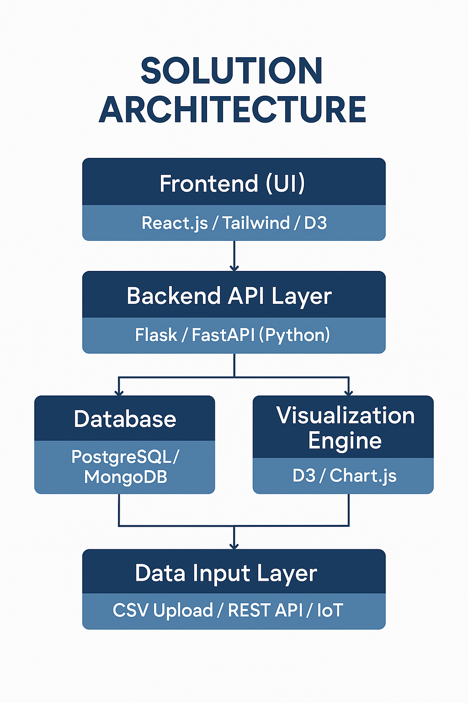

**Component-Based Architecture**

**Key Modules:**

* **Frontend:** Visual interface with filters, dashboards, and interactive elements
* **Backend:** Handles data ingestion, processing, and REST API services
* **Database:** Stores user data, trip logs, charge sessions, and predictions
* **Visualization Engine:** Creates dynamic graphs and maps
* **External APIs (optional):** Google Maps API, EV telemetry APIs, weather data

**5.1 Project Planning**

Effective planning is critical for the successful execution of the project. The development of the **Visualization Tool for Electric Vehicle Charge and Range Analysis** will follow an **agile-based incremental approach**, ensuring continuous integration, testing, and user feedback throughout the lifecycle.

**Phases of Project Development**

| **Phase** | **Timeline** | **Key Activities** |
| --- | --- | --- |
| **1. Requirement Gathering & Analysis** | Week 1 | Understand user needs, finalize feature list, create use cases and personas |
| **2. System Design** | Week 2 | Prepare system architecture, data flow diagrams, UI mockups |
| **3. Frontend Development** | Weeks 3–4 | Design responsive UI, dashboard layout, integrate chart and map libraries |
| **4. Backend Development** | Weeks 4–5 | Develop REST APIs, handle data ingestion, session management |
| **5. Database Setup** | Week 5 | Design schema, implement data storage using PostgreSQL or MongoDB |
| **6. Data Integration** | Week 6 | Enable CSV/API-based data input, connect telemetry if available |
| **7. Visualization Module Development** | Week 7 | Develop graphs, maps, filters, comparison tools |
| **8. Testing & Bug Fixing** | Week 8 | Unit testing, integration testing, UX feedback |
| **9. Deployment** | Week 9 | Host the tool on cloud (e.g., AWS, GCP), setup CI/CD |
| **10. Final Review & Documentation** | Week 10 | Prepare user manual, generate reports, gather feedback |

**Team Members and Role Distribution**

| **Name** | **Role** | **Responsibilities** |
| --- | --- | --- |
| **YJ Hariharan** | *Backend Developer & Data Engineer* | - Design and implement backend architecture (Flask / FastAPI)  - Handle EV data processing (CSV/API)  - Build and maintain RESTful APIs  - Integrate database (PostgreSQL / MongoDB)  - Develop predictive range algorithms |
| **S. Hemanth** | *Frontend Developer & UI/UX Designer* | - Design intuitive user interface using React.js and Tailwind CSS  - Implement dynamic dashboards and visualizations using Chart.js / D3.js  - Integrate maps (Leaflet.js) for charge and range overlays  - Ensure responsive design and good user experience  - Work on report generation and user interaction features |

**6.1 Performance Testing**

**Performance Testing** evaluates how well the visualization tool handles various levels of load, responsiveness, and stability under real-world usage conditions. It ensures that the application can scale, respond quickly, and deliver a smooth experience even when handling large datasets or concurrent users.

**Objectives of Performance Testing**

* To ensure **fast response times** for dashboard visualizations and API requests
* To evaluate **scalability** of the backend when handling high user traffic
* To monitor **system resource usage** (CPU, memory, DB load) under stress
* To assess **data rendering efficiency** for large input files (e.g., >10,000 trip entries)

**Performance Testing Parameters**

| **Metric** | **Expected Performance** |
| --- | --- |
| **API Response Time** | < 500ms for single requests under normal load |
| **Dashboard Load Time** | < 3 seconds for visualizing up to 1,000 data points |
| **Data Upload Time** | < 5 seconds for 5MB CSV or equivalent API input |
| **Concurrent Users** | Stable performance with up to 100 simultaneous users |
| **Memory Usage** | Remains within optimal server threshold |

**Types of Performance Tests Performed**

| **Test Type** | **Description** |
| --- | --- |
| **Load Testing** | Simulate concurrent users uploading EV data and accessing dashboards. Evaluates how the system handles normal and peak traffic. |
| **Stress Testing** | Push the system beyond its capacity (e.g., 10x users or 50MB data files) to check breaking points and error handling. |
| **Spike Testing** | Introduce sudden bursts in user activity (e.g., 50 users logging in at once) to observe system reaction. |
| **Scalability Testing** | Measure how the tool scales as more users or data are introduced over time. |
| **Endurance Testing** | Run system under sustained load for extended periods to detect memory leaks or performance degradation. |

**Testing Tools Used**

* **Postman + Newman** – for API load testing
* **Apache JMeter** – for concurrent user and stress testing
* **Lighthouse / Chrome DevTools** – for frontend performance audit

**8. ADVANTAGES & DISADVANTAGES**

**Advantages**

| **Advantage** | **Description** |
| --- | --- |
| **User-Friendly Visuals** | Converts complex EV charge and range data into interactive, intuitive graphs and maps. |
| **Improved Decision Making** | Enables EV users to plan trips, manage charging habits, and monitor efficiency more effectively. |
| **Real-Time Insights** | Offers real-time updates on battery status, charging sessions, and range predictions. |
| **Customization** | Provides filtering options for trip type, terrain, time period, and more, tailored to user needs. |
| **Predictive Analysis** | Uses historical data to estimate future driving range, improving confidence and planning. |
| **Environmental Awareness** | Encourages energy-efficient driving by visualizing energy consumption patterns. |
| **Scalable Architecture** | Can be adapted to handle growing datasets, user bases, and new vehicle models. |

**Disadvantages**

| **Disadvantage** | **Description** |
| --- | --- |
| **Data Dependency** | Accuracy heavily relies on the quality and completeness of input data from the EV or telemetry systems. |
| **Initial Learning Curve** | Some users may take time to understand how to interpret the visualizations or apply insights. |
| **Connectivity Required** | Real-time features require internet access or continuous data synchronization with EV systems. |
| **Limited Compatibility** | May require additional development to support different EV brands or models with varied data formats. |
| **Security Concerns** | Handling user trip data and location info must be secured to avoid privacy issues. |
| **Backend Load with Big Data** | Handling and rendering large-scale historical data might affect performance if not optimized. |

**9. CONCLUSION**

The **Visualization Tool for Electric Vehicle Charge and Range Analysis** effectively addresses the growing need for intuitive, data-driven interfaces that help EV users monitor and optimize their vehicle performance. By transforming raw EV telemetry into actionable insights through charts, maps, and predictive analytics, the tool empowers users to make informed decisions related to charging behavior, range planning, and energy consumption.

The project successfully integrates front-end visual components with back-end data handling and processing to deliver a seamless user experience. The modular architecture and responsive design ensure the tool can be scaled and adapted for various EV models and user types.

This project not only contributes to improving individual EV usage but also supports larger sustainability goals by promoting efficient energy use and reducing range anxiety.

**10. FUTURE SCOPE**

**1. Integration of Machine Learning**

To enhance the accuracy of range predictions, future versions of the tool can incorporate machine learning algorithms. These algorithms can analyze historical data, driving patterns, road conditions, terrain, and weather to offer more precise and personalized estimations of battery usage and remaining range.

**2. Mobile Application Development**

Creating a dedicated mobile application will allow users to access the tool anytime and anywhere. A mobile version could offer features such as offline access, push notifications for battery alerts or charging needs, and better integration with smartphones and EV mobile platforms.

**3. Real-Time Telemetry Integration**

Currently, data may need to be uploaded manually or fetched via APIs. Future enhancements could include real-time data streaming using IoT devices connected to the EV. This would provide continuous updates without user intervention, improving accuracy and automation.

**4. Multi-Vehicle and Fleet Support**

The tool can be scaled to support multiple vehicles simultaneously, which would be especially useful for fleet operators. This feature would allow users to compare vehicle efficiency, charging behaviors, and range patterns across different cars in a fleet.

**5. Charging Station Integration**

Integration with external APIs to display real-time data from nearby charging stations—such as availability, pricing, and connector types—would help users make informed decisions during long trips or daily commutes.

**6. Environmental Impact Insights**

Future versions could include analytics to calculate the carbon footprint savings achieved by using an EV. Visualizing these savings would not only raise environmental awareness but also encourage energy-efficient driving behavior.

**7. Voice and Chatbot Assistance**

To enhance accessibility, especially for visually impaired or hands-free users, voice command capabilities or chatbot integration could be introduced. This would allow users to query battery status, plan trips, or view charging stats through simple spoken or text commands.